Our English text is…
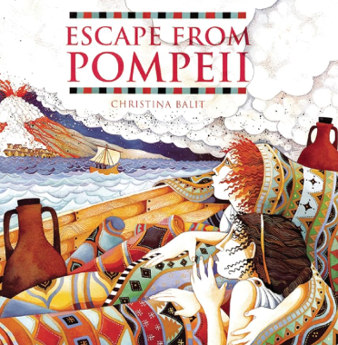

Genre: Fiction
Our writing: Poetry
We will use a range of teaching techniques to support writing to develop confident writers working on individual targets.
Themes:
"Escape from Pompeii" is a historical fiction story set in AD 79. It follows Tranio, the son of an actor, and his friend Livia, the baker's daughter, as they witness the eruption of Mount Vesuvius from a boat in the harbor. The book provides a first-hand account of the destruction of Pompeii and is noted for its engaging story and illustrations, making it suitable for children learning about Roman history.
Key vocabulary: volcano , erupt, destroy, lava
Author: Christina Balit

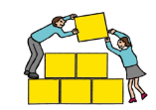Sprowston Junior School SHIP Autumn 2
Fine motor skills
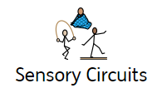

We start every day with fine motor control activities. The ability to use hands and fingers accurately helps develop tactile awareness, hand strength and visual spatial perception. We also do a sensory circuit every day.

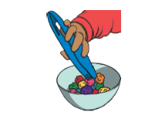
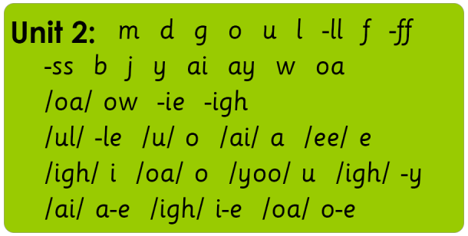
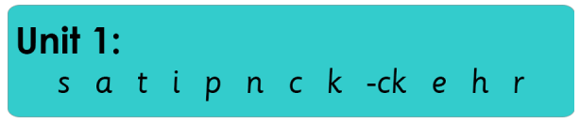
Cookery/Art
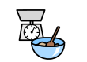
We will be making a variety of dishes and ensure the children can understand and apply the principles of a healthy and varied diet. We will also look at making some sculptures of landmarks in capital cities and models of minibeasts.
Children will develop their skills in weighing and measuring as well as learning about food hygiene. Children will take turns and support each other as well as making delicious treats. Children will also develop their art and DT skills through sketching, cutting, designing creating and evaluating.
Phonics
We have a focused phonics session every day.

During their time at the SHIP, pupils will develop
their confidence in phonics by engaging in a daily
systematic, synthetic phonics programme. They
will learn a range of self-support and strategy skills
which will enable them to link reading, sounding,
spelling and writing together.
Pupils will also have the opportunity to use and
apply these skills during a dedicated session.
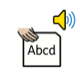

Shared Reading
Our shared reading sessions give children the opportunity to read books which are interesting to them with the support of a peer and an adult. They will see new vocabulary and experience being immersed in a text, building their reading for pleasure alongside their decoding skills.
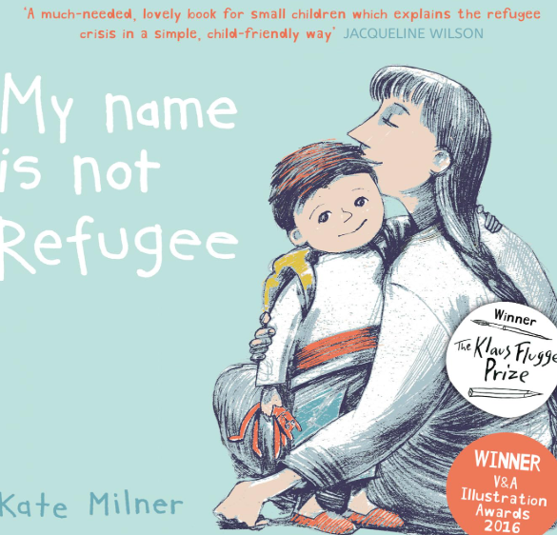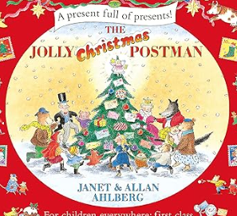
Focusing on themes of identity and belonging, this non-fiction book explores how it would feel to make decisions to leave family and friends
Our Christmas read focusses on traditional fairy tales and getting letters.

Confidence and Independence
Through our 1 to 1 ELSA sessions and PSHE sessions we will build our confidence, self-esteem and team work skills. We will also spend time using Zone of Regulation to identify strategies to help us with dealing with our different feelings.
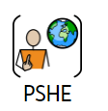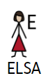
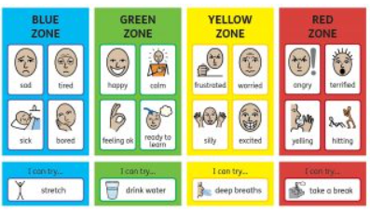


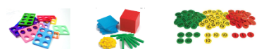
Topic

Our topic this half term is: Romans

We link our topic to our book for an immersive learning experience. Learning objectives this half term will include a study of the Romans their Gods, their Empire, their army, and how Roman times affect out lives now.

We will be able to:

Talk about what daily life was like for Roman soldiers.

We will learn how they lived including the Roman baths, how the built roads.

Maths
We use a CPA (concrete, pictorial, abstract) approach in every maths lesson. Pupils will experience using a range of concrete materials to support learning.

Pupils will focus on developing their understanding of place value, the four operations (including written methods) and remembering and recalling time tables facts. Maths objectives and targets are carefully differentiated to meet the needs of the pupils.
Autumn 2 maths topics: Multiplication and division, Addition and Subtraction. YR R 1//3/4/5/6 curriculum objectives (according to ability). Pupils will also access the online maths programme Times Tables Rockstars. Their log in details will be shared with home so that they can access this anytime.
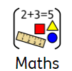

Key word spellings – a multi-sensory approach
We use a multi-sensory approach to learning and spelling new words. Pupils are encouraged to sculpt high frequency words using play dough and create a model of meaning.

This method aids
long term memory
recall skills.

Memory games
We play memory or processing games. They are a great way to support development. These games help to hone memory skills, help learn strategy, force us to think, teach concentration, and improve their reflexes
We will also work on focussing our attention with a variety of activities to help develop active listening and improve focus.



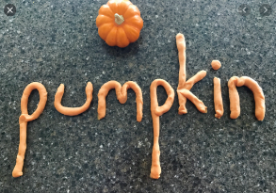

PE –This term the children will be on a Tuesday. Children should wear their PE kits on this day. We may be outside or inside depending on the weather.PE lessons are based around core and gross motor strength and control including skills and games. We are focussing on rugby, tennis and athletics.
Please bring a water bottle and wash it thoroughly every day. 

Life Skills

Our topic this half term is: Library

We will visit the library -look at and borrow books.

The New build

We will be visiting the new build often and watch as it progresses. We should have a roof by the end of November. The children each have their own hard hats and high viz jackets.

