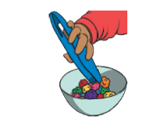

Our English text is…
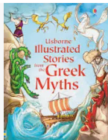
Theseus and the Minotaur

Genre: Fiction
Our writing: Part of a myth -character description
We will use a range of teaching techniques support writing to develop confident writers working on individual targets..
Themes: King Aegeus of Athens had to send 9 people every year to a Labyrinth in Crete to revenge King Minas’ son’s death. The minotaur half man half bull eats people. Theseus decides to tackle the monster. Ariadne gives him a ball of string. He promised he would marry her. He escaped the labyrinth and the minotaur. He didn’t want to marry her, so Ariadne asked the gods to make the sailors forget to change the colour of the sail. King Aegeus thought Theseus had died.
Key vocabulary: minotaur Labyrinth Gods
Author: Russell Punter
Illustrator: Linda Cavallini
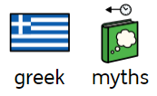
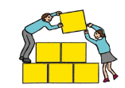Sprowston Junior School SHIP Autumn 2
Fine motor skills


We start every day with fine motor control activities. The ability to use hands and fingers accurately helps develop tactile awareness, hand strength and visual spatial perception. We also do a sensory circuit every day.

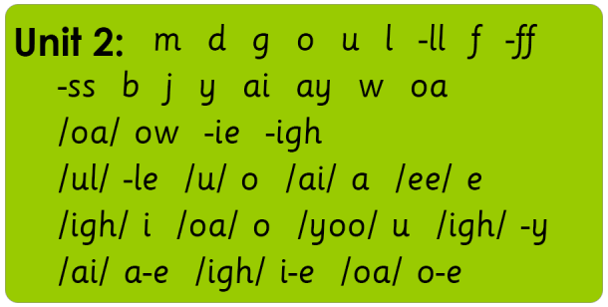
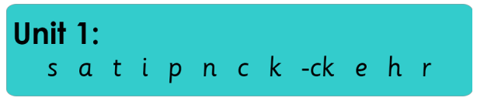
Phonics
We have a focused phonics session every day.

During their time at the SHIP, pupils will develop
their confidence in phonics by engaging in a daily
systematic, synthetic phonics programme. They
will learn a range of self-support and strategy skills
which will enable them to link reading, sounding,
spelling and writing together.
Pupils will also have the opportunity to use and
apply these skills during a dedicated session.
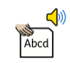

Cookery/Art
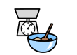
Every week we will be working with
the pupils to ensure they can understand and apply the principles of a healthy and
varied diet. Children will develop their skills in weighing and measuring as well as learning about food hygiene. Working in groups, children will take turns and support each other as well as making delicious treats! Children will cook in groups every other week. Children will also develop their art skills.
Shared Reading
Our shared reading sessions give children the opportunity to read books which are interesting to them with the support of a peer and an adult. They will see new vocabulary and experience being immersed in a text, building their reading for pleasure alongside their decoding skills.
Who you were meant to be. Joanna Gaines 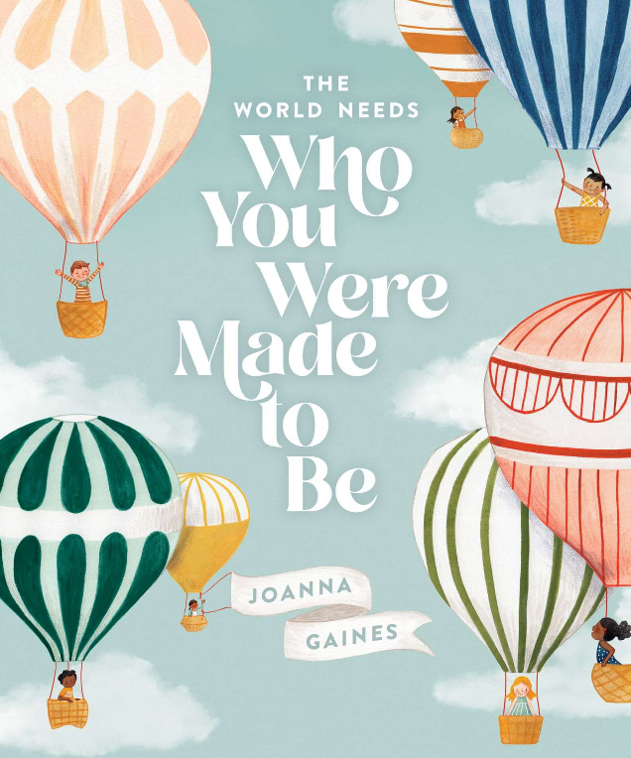 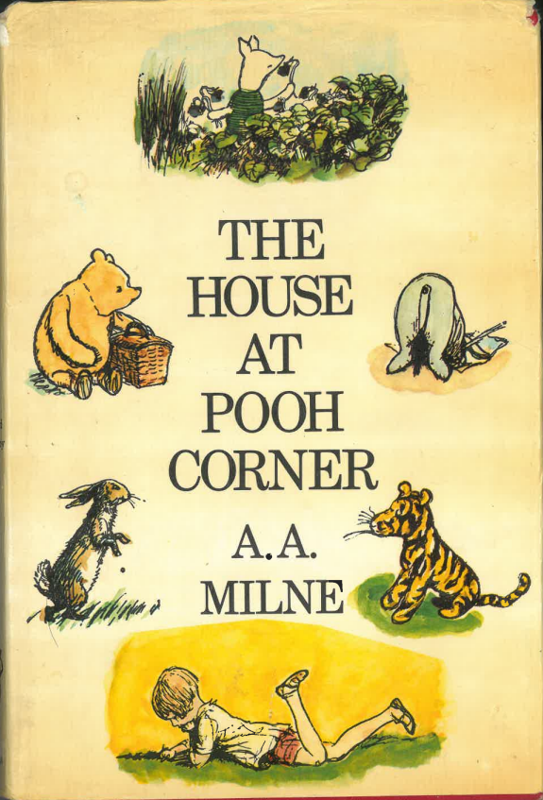 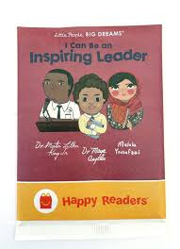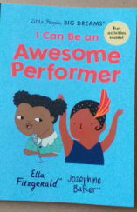
Winnie the Pooh AA Milne
Little People Big Dreams
I can be an Inspiring Leader I can be an awesome performer.

Confidence and Independence
Through our 1 to 1 ELSA sessions and PSHE sessions we will build our confidence, self esteems and team work skills. We will also spend time using Zone of Regulation to identify strategies to help us with dealing with our different feelings.
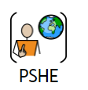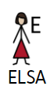
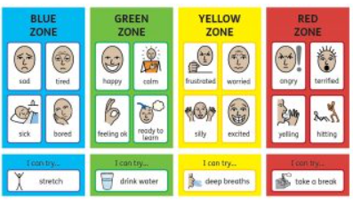

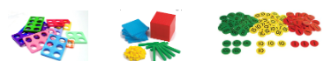

Maths
We use a CPA (concrete, pictorial, abstract) approach in every maths lesson. Pupils will experience using a range of concrete materials to support learning.

During their time at the SRB pupils will focus on developing their understanding of place value, the four operations (including written methods) and remembering and recalling time tables facts. Maths objectives and targets are carefully differentiated to meet the needs of the pupils.
Autumn 2 maths topics:, addition and subtraction, multiplication and divsition YR2/3/4/5/6 curriculum objectives (according to ability). Pupils will also access online maths programme Times Tables Rockstars. Their log in details will be shared with home and home school settings so that they can access this anytime. 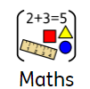

Topic

Our topic this half term is: Ancient Greeks.
History

We link our topic to our book for an immersive learning experience. Learning objectives this half term will include a study of Greek life and achievements and their influence on the western world.

We will be able to:
Identify primary and secondary sources
Recall origins of alphabet, democracy and theatre and Olympic games.

We will learn how the Ancient Greeks affect our
lives today.
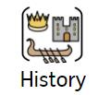

Key word spellings – a multi-sensory approach
We use a multi-sensory approach to learning and spelling new words. Pupils are encouraged to sculpt high frequency words using play dough
and create a model of
meaning. This method
aids long term memory
recall skills.

Memory games
We play a memory or processing game every afternoon. They are a great way to support development. These games help to hone memory skills, help learn strategy, force them to think, teach concentration, and improve their reflexes
We will also work on focussing our attention with a variety of activities to help develop active listening and improve focus.





PE – PE will be every Tuesday. Children should wear their PE kit to school on this day. PE lessons are based around core and gross motor strength and control including skills and games Please bring a water bottle and wash it thoroughly every day. 

