Our English text is…


Genre: Non- Fiction
Our writing: Non- chronological reports.
We will use a range of teaching techniques tp support writing to develop confident writers working on individual targets.
Themes: This book focusses on Habitats and the animals that live in them.
Key vocabulary: camouflage, adapt, habitat, survive, hunt, prey, classification.
Author: David Attenborough

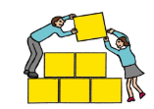Sprowston Junior School SHIP Summer 2
Fine motor skills
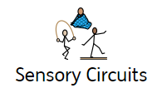

We start every day with fine motor control activities. The ability to use hands and fingers accurately helps develop tactile awareness, hand strength and visual spatial perception. We also do a sensory circuit every day.

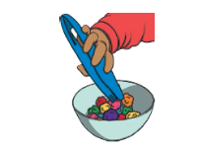
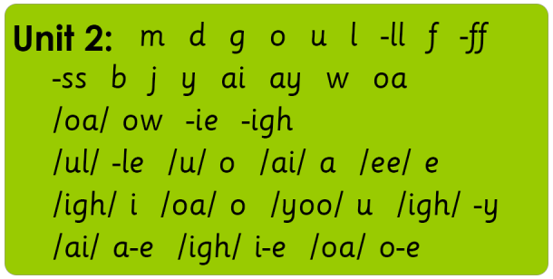
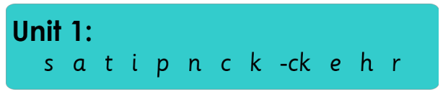
Cookery/Art
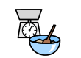
We will be making some food from different countries and ensure they can understand and apply the principles of a healthy and varied diet. We will also look at making some sculptures of landmarks in capital cities and models of minibeasts.
Children will develop their skills in weighing and measuring as well as learning about food hygiene. Children will take turns and support each other as well as making delicious treats. Children will also develop their art and DT skills through sketching, cutting, designing creating and evaluating.
Phonics
We have a focused phonics session every day.

During their time at the SHIP, pupils will develop
their confidence in phonics by engaging in a daily
systematic, synthetic phonics programme. They
will learn a range of self-support and strategy skills
which will enable them to link reading, sounding,
spelling and writing together.
Pupils will also have the opportunity to use and
apply these skills during a dedicated session.
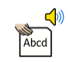

Shared Reading
Our shared reading sessions give children the opportunity to read books which are interesting to them with the support of a peer and an adult. They will see new vocabulary and experience being immersed in a text, building their reading for pleasure alongside their decoding skills.
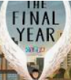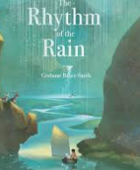
Year 6 will continue to look at The Final Year. We will look at the rhythm of the rain as part of our study of the water cycle.

Confidence and Independence
Through our 1 to 1 ELSA sessions and PSHE sessions we will build our confidence, self-esteem and team work skills. We will also spend time using Zone of Regulation to identify strategies to help us with dealing with our different feelings.
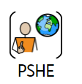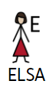
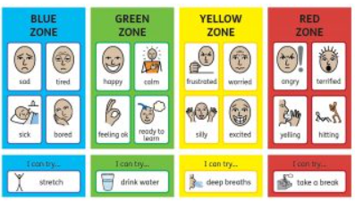


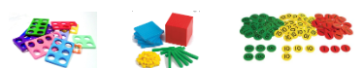
Topic

Our topic this half term is: Habitats

We link our topic to our book for an immersive learning experience. Learning objectives this half term will include a study of habitats, and the animals that live in them. We will look at what they eat and how animals are adapted to live in their habitats.
We will also learn about what living things need to survive.
We will be able to:
Understand how animals are adapted to their habitats.
Understand that animals can be classified.
Interpret classification keys.
We will learn how to write a non-chronological reports on habitats and the animals that live in them.


Maths
We use a CPA (concrete, pictorial, abstract) approach in every maths lesson. Pupils will experience using a range of concrete materials to support learning.

Pupils will focus on developing their understanding of place value, the four operations (including written methods) and remembering and recalling time tables facts. Maths objectives and targets are carefully differentiated to meet the needs of the pupils.
Summer 2 maths topics: fractions, time money and statistics. YR R 1//3/4/5/6 curriculum objectives (according to ability). Pupils will also access online maths programme Times Tables Rockstars. Their log in details will be shared with home so that they can access this anytime. 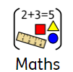

Key word spellings – a multi-sensory approach
We use a multi-sensory approach to learning and spelling new words. Pupils are encouraged to sculpt high frequency words using play dough
and create a model of
meaning. This method
aids long term memory
recall skills.

Memory games
We play a memory or processing game. They are a great way to support development. These games help to hone memory skills, help learn strategy, force us to think, teach concentration, and improve their reflexes
We will also work on focussing our attention with a variety of activities to help develop active listening and improve focus.





PE –This term the children will be on a Mondays. Children should wear their PE kits on this day. We may be outside or inside depending on the weather.PE lessons are based around core and gross motor strength and control including skills and games . We are focussing on rugby, tennis and athletics. Please bring a water bottle and wash it thoroughly every day. 

