Y3 Knowledge Organiser
Savage Stone Age
Key Question: How did a Stone Age person survive?

Key vocabulary and definitions
- Stone Age – 3 million to 6000BC
- Archaeology – to find historical treasures
- Palaeolithic- (roughly 2.5 million years ago to 10,000 B.C.), early humans lived in caves or simple huts
- Mesolithic- 'Middle-Stone Age' ran from about 9000-4300 years ago
- Neolithic- from around 4300 BC down to 2000 BC. Neolithic means 'New Stone' and so this period is sometimes called the New Stone Age.
- Hunter-gatherer
- Skara Brae
- Stonehenge
- Flint – sharp stone
- Woolly mammoth
- Saber tooth tiger
- Camp fire
- Knives, scrapers, hand axes, were all used as tools.

Important facts
- The Stone Age was a very long time ago
- An archaeologist looks into the ground to find historical evidence.
- Stone Age houses were very different to ours now, they have evolved (changed a lot).
- During the Stone Age the wheel was invented- it was made of stone!
- Stone Age people hunted for animals to eat.
- Stone Age people gathered food from the land around them.
- Stone Age people made their own weapons- often using stones to create the sharp points.
- A fire was used for warmth, cooking and to frightening away the animals.
- Stone Henge and Skara Brae are prehistoric places, where people gather.
- Stone Age people painted on cave walls to share their stories.

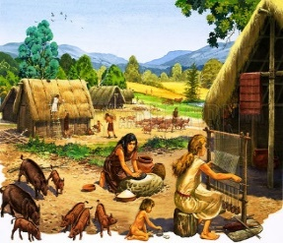
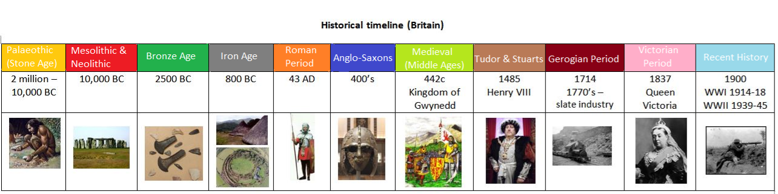
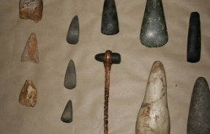
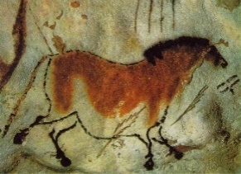
Golden word
invention
Stone Age time


