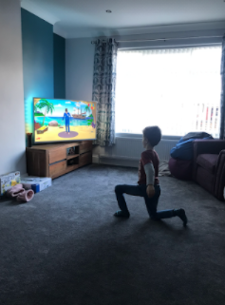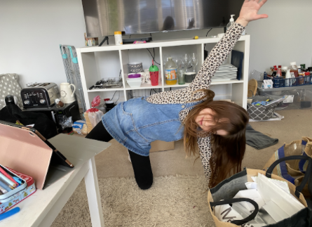We feel really sad that we haven’t had a ‘normal’ year so far and that we have been unable to learn altogether but here are some pictures to show the learning we have done whether in school or at home. It would be nice if you and your child could talk through them together.

DT/Science: Designing, making and evaluating bird feeders

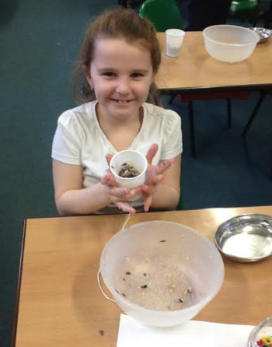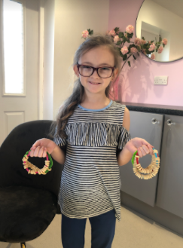  
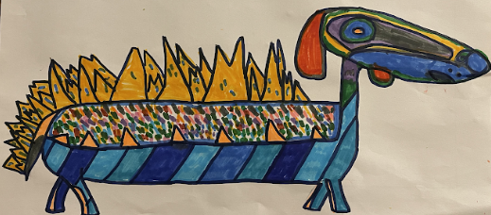

PSHE: Learning about uniqueness.

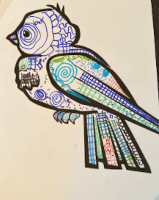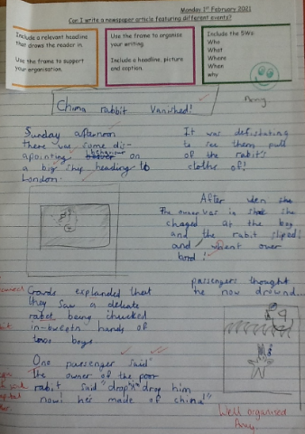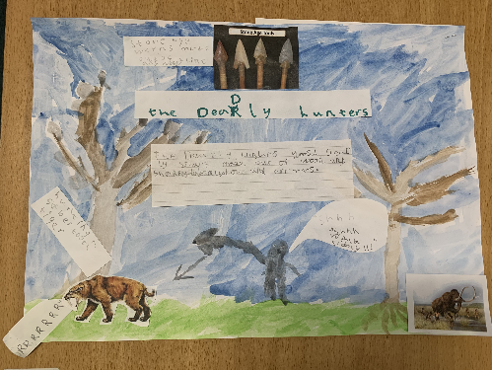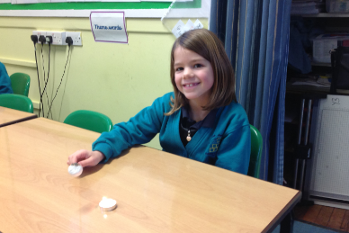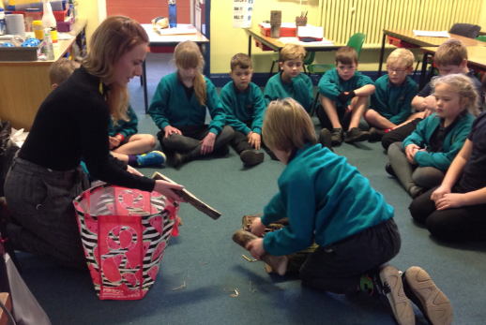

PE: Practising different styles of yoga.

History: Learning all about the Stone Age, including making and cooking on a fire

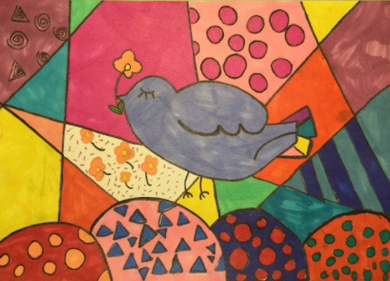

Literacy: Writing great non-fiction

pages in the style of ‘The Secrets of Stonehenge’ and creating newspapers linked to ‘Edward Tulane’

ART: We have focused on birds- linking to the BIG bird watch. Creating birds in different style.